

**“Arah Langkah Tour & Travel”**

Group 6

Name : 1. Bagas Ade Satria

2. Vita Rasya

Class : 3SC8

Faculty : Fachran Nazarullah

CEP CCIT

FAKULTAS TEKNIK UNIVERSITAS INDONESIA

2019

**Project On**

Arah Langkah Tour & Travel Website

Developed by :

**GROUP 6**

1. Bagas Ade Satria

2. Vita Rasya

NIIT

**Course Management Application**

Batch Code : 3SC8

Start Date :

End Date :

Name Of The Coordinator : Fachran Nazarullah

Name Of Developer : Bagas Ade Satria

Vita Rasya

Date Of Submission :

NIIT

**CERTIFICATE**

This is to certify that this report, titled ***“Arah Langkah Tour & Travel”***, embodies the original work done by ***Bagas Ade Satria*** and ***Vita Rasya*** inpartial fulfillment of his course Requitment at NIIT.

Coordinator: Fachran Nazarullah

**Acknowledgement**

Praise and huge thanks to Allah SWT for giving us blessings, health, ability to be able to finish this Project with the title “Arah Langkah Tour & Travel”, without any of it we won’t be able to complete it right on time. Despite many hurdles and obstacles that we experienced in the course of the work, but we managed to finish it properly. We have benefited a lot from the feedback and suggestions given to us by Mr. Fachran Nazarullah.

**System Analysis**

**System Summary :**

Arah Langkah Tour & Travel is a website that provides trip and travel facilities in exploring the wonderful mountains in Indonesia. And Arah Langkah also offering other Indonesia’s beautiful tourist destinations, and aiming to go international in the near future. Different from other travel tours, Arah Langkah will select participants who will join the mountain ride with our tour travel.

**Introduction**

Arah langkah is Adventure, Tour, and Travel Organizer who are engaged in the adventure on the mountain especially mountain in Indonesia. And Arah Langkah also offering other Indonesia’s beautiful tourist destinations.

Different from other travel tours, Arah Langkah will select participants who will join the mountain ride with our tour travel. Because in Arah Langkah there will always be guest stars like artists, singers, etc. who also like hiking. And in our tour it is also filled with education about nature and we hope that the guest star can influence many people to always care for our nature, especially for Indonesia.

**Activity List**

* October 07, 2019 : Discussion the topic
* October 10 , 2019 : Make an index page
* October 15, 2019 :
* October 17, 2019 :
* October 20, 2019 :
* October 25, 2019 :
* October 27, 2019 :
* October 28, 2019 : Make the angular and json.
* October 30, 2019 : Make the report and and power point presentation.

**Design of Apps**

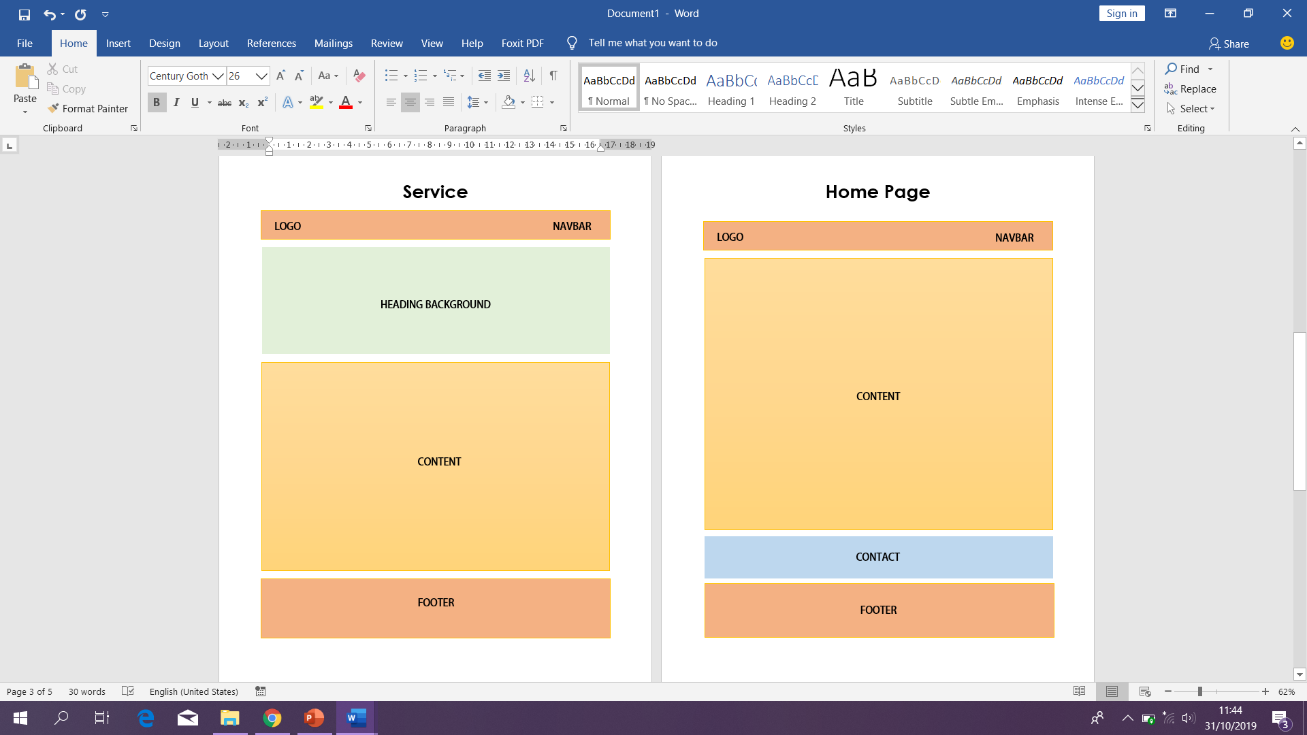

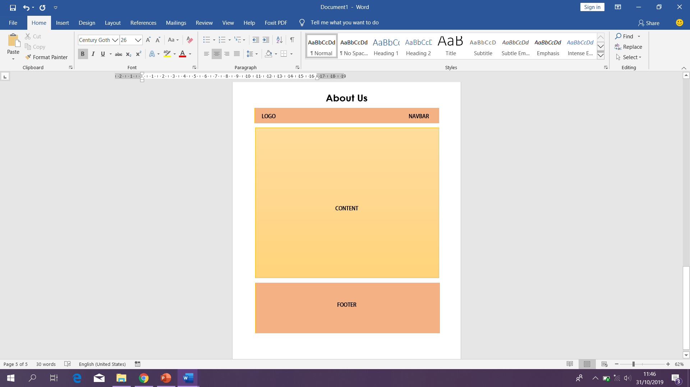

**Design of Apps**



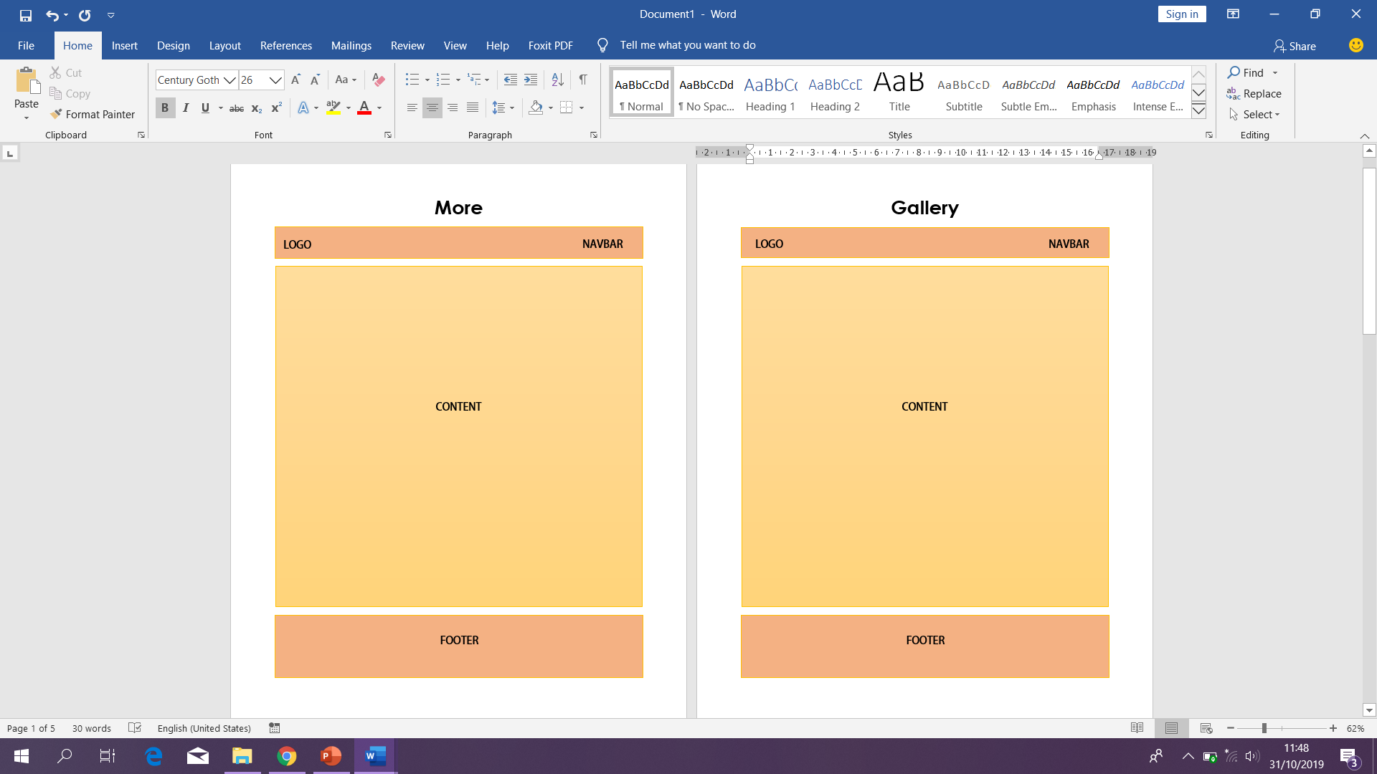

**Design of Apps**

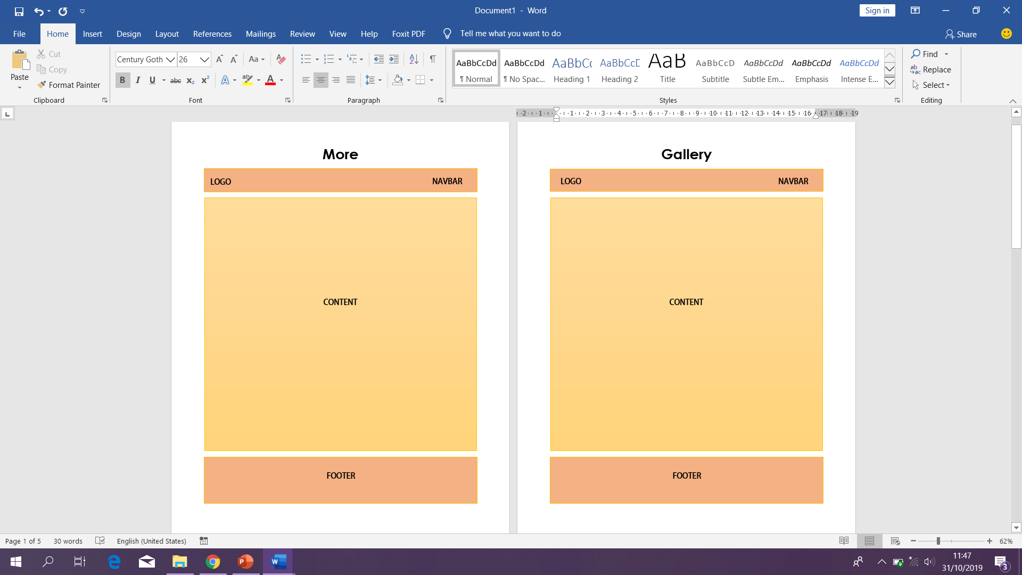

**Implementation**

* HTML5 :
* Angular :
* Json :
* Github :

**Preview of Apps**

Application Preview using Screenshot :

Home Page

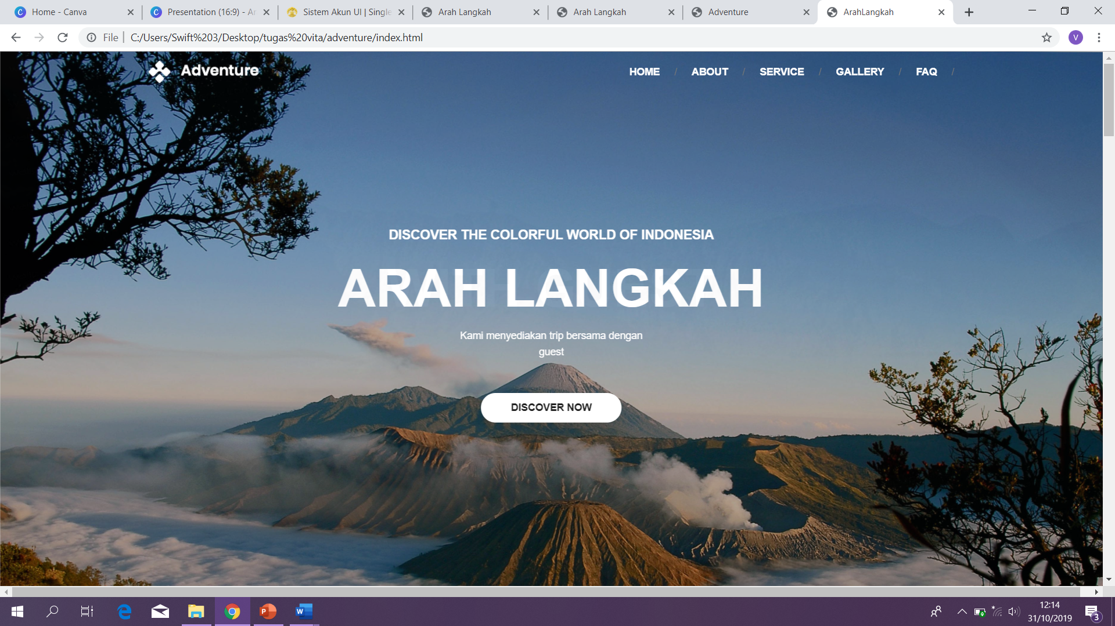

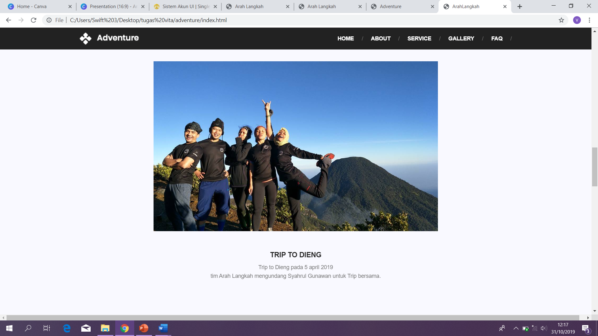

**Preview of Apps**

Application Preview using Screenshot :

About Us

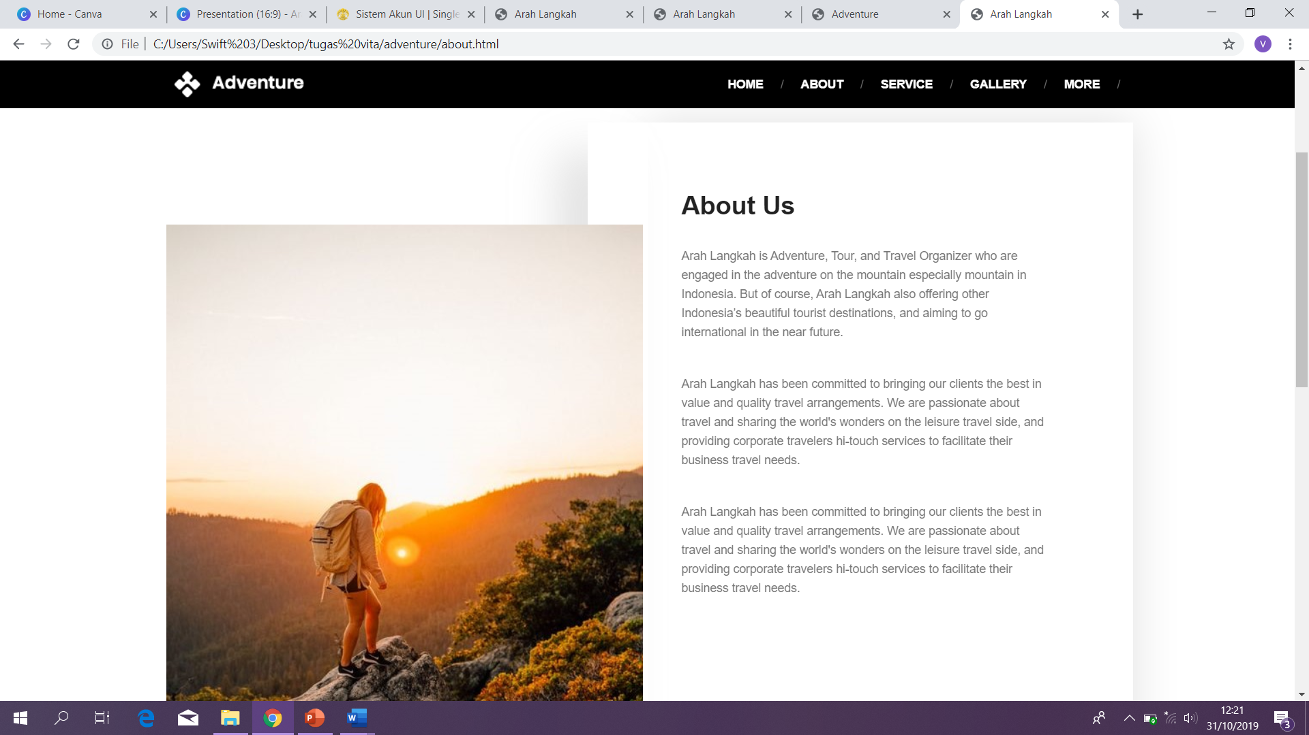

Gallery

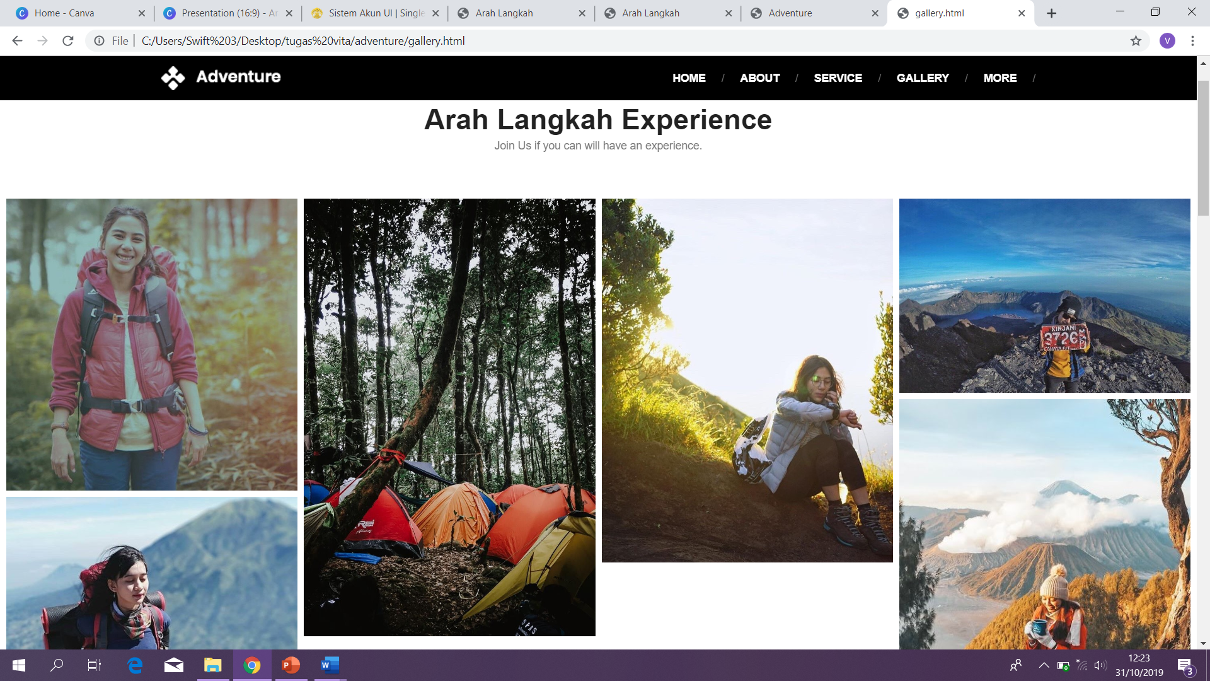

**Preview of Apps**

Application Preview using Screenshot :

Service

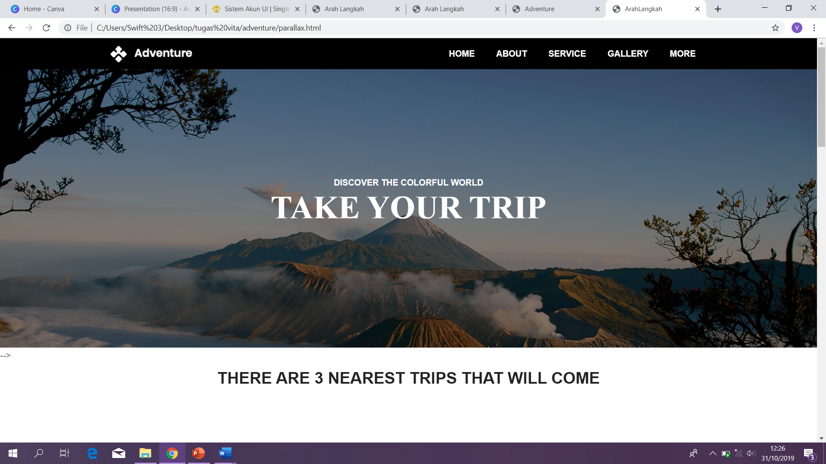

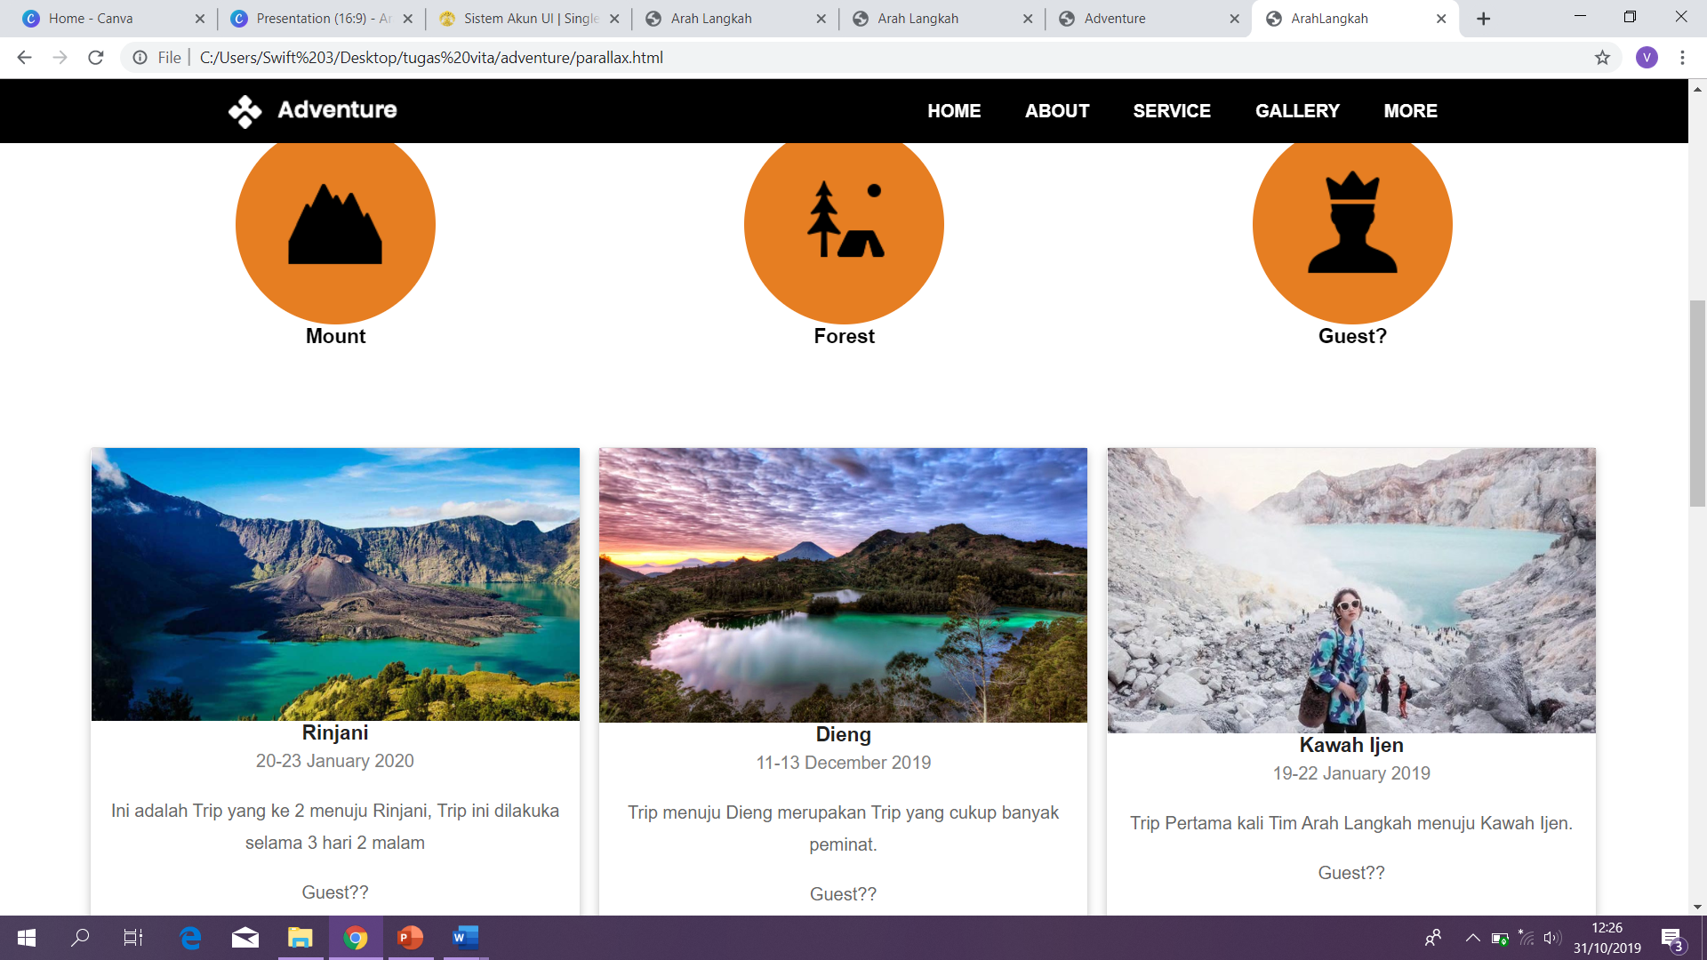

**Configuration**

# Hardware : Asus VivoBook 14 coretm i7 ram 8gb

**Operating System :** Windows 10

**Software :** Visual Studio Code

**Project File Details**

|  |  |  |
| --- | --- | --- |
| **No.** | **File Name** | **Remarks** |
| 1. | arahlangkah.html | A file that contain all the web pages, css, javascript, jQuery and image. |
| 2. | arahlangkah.docs | Microsoft Word Document that contain report. |
| 3. | arahlangkah.pptx | Microsoft Power Point that contain presentation. |